Group exhibition
“Everything Will Be Alright: Tomorrow or Someday”
Baku, Azerbaijan

6 july – 8 december, 2024

Press – release

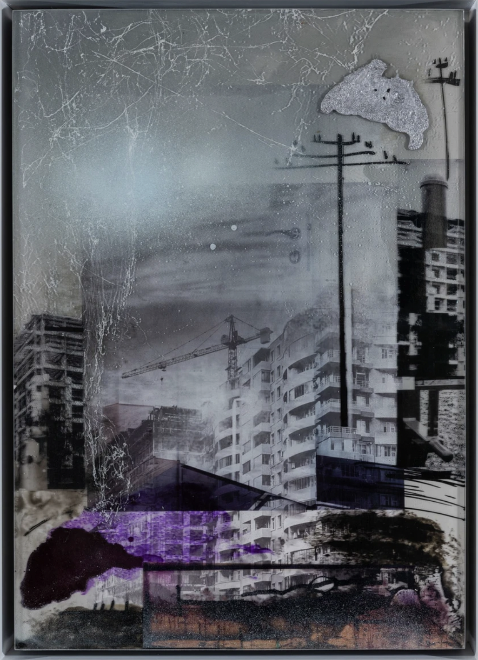
Aida Mahmudova, Composition 6, 2022 /
Photography, Mixed Media / 65 x 47,6 x 6 cm

YAY Gallery is thrilled to announce its relaunch! This time, YAY presents a group exhibition called “Everything Will Be Alright: Tomorrow or Someday” consisting of the works of Rasim Babayev, Elshan Baba, Tarlan Gorchu, Orkhan Huseynov, Aida Mahmudova, Gafar Rzayev, Zamir Suleymanov, and CHINGIZ.

Curated by Zahra Mammadova

“Art is the highest form of hope”
Gerhard Richter

In this exhibition, the viewer is confronted with the meditation that art is both a mirror and a remedy, urging us to consider its power to drive change. Eight artists with diverse practices have come together, each offering a unique perspective on this transformative force—parallel truths that overlap and interconnect.

Here, we explore various themes: from contemporary dilemmas to introspective journeys. Artists delve into liminal spaces, seeking meaning amidst the complexities of time and place. They tackle identity, prompting us to reflect on who we are and where we stand. The exposition embodies the “diaries” that make sense perhaps personally to the artists themselves, yet resonate and also reflect the collective experiences.

Embedded within their work is a dialogue with our socio-political reality—a raw conversation that speaks to the soul. What is more naked standing bare in front of the questions? Questions arise, challenging us to consider conflicts and chaos while finding beauty and purpose within. Each artist is somewhat of a prophet of their era, inviting us to find meaning in their narratives.

The exhibition aims to incite a seed for thought for it to grow bigger and find belief in the power of art in difficult times. Through narrating, we find continuity and hope. As long as artists continue to share their stories and visions, we can find solace and the promise of a better future.

About YAY:

Established in 2012, YAY Gallery is located in the heart of Baku’s Old City which sits amongst designated UNESCO world heritage sites.

The gallery was founded by YARAT Contemporary Art Space, a non-profit organization committed to supporting the art infrastructure in Azerbaijan.
The primary activity of YAY Gallery is to organize exhibition-sales events featuring works by talented and promising young artists from Azerbaijan and other countries, as well as by renowned and experienced artists. The revenue generated from the sale of artworks is shared between the artists and the YARAT organization.

Another priority of YAY Gallery is to serve as a platform for the exchange of ideas and experiences by organizing lectures, seminars, film screenings, and other events conducted by artists and professionals working in the field of art.

Exhibition duration:
6 july – 8 december, 2024
Working hours:
Tuesday – Sunday, 12:00 – 20:00
Address: 5 Kichik Gala St.
Free admission, all the artworks are for sale.

About media and for images contact:
Hokuma Karimova
Phone.: +994 50 207 8007
E-mail: hokuma.k@yarat.az

www.yaygallery.az

