PRESS RELEASE

 | 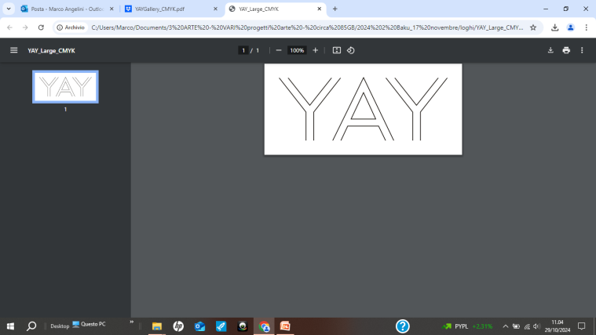
MARCO ANGELINI
Light as a Metaphor for Energy Transition
Solo exhibition

Curated by: Jan Kozaczuk

The solo exhibition of Italian artist Marco Angelini, organized by the Italian Embassy in Azerbaijan in partnership with YAY Gallery, coinciding with the 29th Conference of the Parties on Climate (COP29), showcases 30 of Angelini’s works, crafted with vivid colour and photovoltaic cells. COP29 serves as a critical platform to explore and develop collaborative strategies for global environmental preservation.

In the exhibition catalogue, curator Jan Kozaczuk writes:
“Marco Angelini, a contemporary Italian artist, explores the intersection of light and matter through his abstract works. His creative process is inspired by a rich historical and scientific legacy, primarily examining how humans perceive light. For Angelini, light transcends its role as a mere expressive tool; it becomes a dynamic, interactive force that draws viewers into a profound visual and reflective experience, actively shaping and transforming the realities it illuminates.
Angelini treats light as something that passes through his work and as an active agent that structures it. His use of light is dynamic, expanding and multiplying to give form, embodying the principle of hoc opus facit—"this light creates the work.” Drawing from humanity’s enduring fascination with light’s ‘magical’ qualities and modern insights into its dual nature as both wave and particle, Angelini demonstrates how light creates depth, movement, and form within the painted space.
His works reflect the rapid technological transformations of our era, offering a multi-layered narrative that addresses the theme of energy transition. Through his art, he captures life’s vitality and resilience, inviting us to illuminate the future through technological advancement and by fostering a more inclusive and socially aware society.”

About the artist: Marco Angelini was born in Rome in 1971 and lives and works between Rome and Warsaw. Trained as a sociologist and driven by his artistic calling, he explores urban phenomena, cultures, and, in particular, the subcultures that emerge in the world’s metropolises.
Cities create environments where unconscious impulses are brought to light, interacting through and with technology, which introduces radical new possibilities. In this way, cities become the nucleus and ideal setting for human paradoxes and contradictions.
Angelini’s artistic research spans diverse themes, often pursued simultaneously: nature and technology, time and memory, interreligious dialogue and the concept of the "sacred," as well as intersections between art and science, energy, and sustainability.
His abstract approach embodies his fluid and evolving aesthetic, suggesting the presence of multiple realities.
Marco Angelini is passionate about art’s potential to play a transformative social role by making unseen things visible, drawing attention to them, and fostering new avenues for sharing, communication, and introspection.
He has held solo exhibitions in Rome, Milan, Warsaw, Krakow, London, Bratislava, Algiers, Santiago de Chile, Bologna, and Marseille, and participated in group exhibitions in public and private galleries across New York, Washington DC, Tel Aviv, Abu Dhabi, Warsaw, Zamość, Szczecin, Munich, Essen, London, Brussels, Rome, Lucca, and Genoa.
His work is held by various collectors, with one piece featured in the private collection of Fondazione Roma.

About YAY Gallery:
Established in 2012, YAY Gallery is located in the heart of Baku’s Old City which sits amongst designated UNESCO world heritage sites.
The gallery was founded by YARAT Contemporary Art Space, a non-profit organization committed to supporting the art infrastructure in Azerbaijan.
​The primary activity of YAY Gallery is to organize exhibition-sales events featuring works by talented and promising young artists from Azerbaijan and other countries, as well as by renowned and experienced artists. The revenue generated from the sale of artworks is shared between the artists and the YARAT Contemporary Art Space organization.
​Another priority of YAY Gallery is to serve as a platform for the exchange of ideas and experiences by organizing lectures, seminars, film screenings, and other events conducted by artists and professionals working in the field of art.
www.yaygallery.az
Exhibition duration: November 18 – December 31, 2024
Working hours: Tuesday - Sunday, 12:00-20:00
Free admission

